**Computer Programming 1  
Essential Standard 4.00 Understand Variables and Naming Conventions**

In all programs, put your name, the assignment name and the date in comments at the top.  
Reminder, put an apostrophe (‘) in front of your line to make it a comment.

1. Create a new project called HelloAgain
   1. Add the controls shown on the form below. Name them appropriately  
      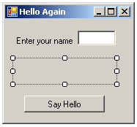
   2. Create a variable for the input *name*.
   3. Display the following message when the button is clicked.  
      Hello, *Your Name*
2. Create a new project called Grades
   1. Add the following controls

|  |  |  |
| --- | --- | --- |
| **Control** | **Name Property** | **Text Property** |
| Form | *You may leave it Form1* | Grades |
| Label | lblGrades | *Empty* |
| Label | lblQ1Prompt | Enter your Quarter 1 Average |
| Label | lblQ2Prompt | Enter your Quarter 2 Average |
| Label | lblFEPrompt | Enter your final exam grade |
| TextBox | txtQ1Grade |  |
| TextBox | txtQ2Grade |  |
| TextBox | txtFEGrade |  |
| Button | btnShowGrade | Your Grade |

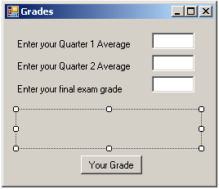

1. For the btnShowGrade control, create a Click event.
   * 1. Declare variables for the quarter 1 average, quarter 2 average and the final exam average. (These are your input variables)
     2. Get the input from your textboxes
        + Example:  
          Dim intQuarter1 As Integer  
          intQuarter1 = txtQ1Grade.Text
     3. Declare a variable for your final grade. (This is your output variable)
     4. Calculate the final grade using the following formula using your own named variables!  
        grade = ( .4 * firstQuarterGrade) + (.4 * SecondQuarterGrade) + (.2 * FinalExamGrade)
     5. Display the grade in your label.
2. Create a new project called Pizza2

|  |  |  |
| --- | --- | --- |
| **Control** | **Name Property** | **Text Property** |
| Form | *You may leave it Form1* | Pizza2 |
| Label | lblOrder | *Empty* |
| Label | lblCrustPrompt | Enter your choice of crust (thin, thick, regular) |
| Label | lblTopping1Prompt | Enter your choice of topping |
| Label | lblTopping2Prompt | Enter your choice of topping |
| TextBox | txtCrust |  |
| TextBox | txtTopping2 |  |
| TextBox | txtTopping3 |  |
| Button | btnYourOrder | Your Order |

* 1. Add the following controls to your form and key their properties as shown in the table.  
       
       
       
       
       
       
       
       
       
       
       
       
       
       
       
       
       
       
       
       
       
       
       
       
     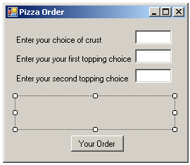
  2. Use the input from the textboxes to get the user’s input.
  3. Display the choices in the label.
  4. Create TextChanged events to clear the label when user runs multiple times.

1. Create a new project called circleArea that prompts the user for a radius, calculates the area of the circle and displays the answer. Declare the appropriate variables for input and output and include a TextChanged event to clear the answer. Declare pi as a constant variable (Const dblPI As Double = 3.14159). Use the formula area = PI * r * r.  
     
   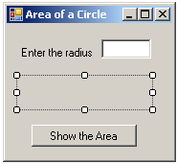
2. Open the HelloAgain project. Remove the label and display your “Hello *yourName*” message in a MessageBox.
3. Create a project called ReadyForSchool. Add the controls shown below, naming them appropriately.  
     
   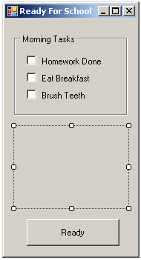  
   1. Create a CheckChanged event for the Homework Done! CheckBox that displays a MessageBox that says “Good Job!” when that CheckBox is done.
   2. As the CheckBoxes are checked, add their messages to the label. Make sure you are using concatenation (&=) with the label.Text so that the message adds. Remember you can go to a new line with vbCrlf.  
      Example:  
      lblMessage.Text &= “*Message here”* & vbCrlf
   3. When the Button is clicked, the label should display the message “Ready for School”
4. Create a project called Scope. Create a global variable called x, set to 10. Create two buttons as shown.   
   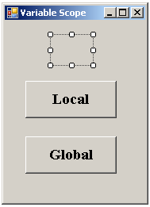  
   1. In the Local button click, declare a variable called x, set to 5. Display the value of x in the label. When clicked, 5 should be displayed in the label.  
      lblScopeAnswer.Text = x
   2. In the Global button click, display the value of x in the label. When clicked, 10 should be displayed in the label.  
      lblScopeAnswer.Text = x
5. Create a project called Counting. Create two buttons as shown.  
   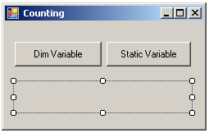  
   1. In the Dim Variable button click
      1. Declare a variable called intCounter and initialize it to 1.
      2. Add the statement below which will add 1 to your variable  
         intCounter = intCounter + 1
   2. In the Static Variable button click
      1. Declare a variable called intCounter and initialize it to 1.
      2. Add the statement below which will add 1 to your variable  
         intCounter = intCounter + 1
   3. When the buttons are clicked, the variable should be displayed in the label.
   4. Run your program and note how the Static variable changes as it holds its value.